 TEAM ID : PNT2022TMID17792



**PrOjEcT DEsIgN PhAsE-1 sOluTION ArchITEcTurE**

**PrOjEcT NAME :IOT BAsED SMArT CrOP**

**PrOTEcTION SysTEM fOr AgrIculTurE**





**cAMErA MODulE**

**IOT BAsED SMArT CrOP**

**PrOTEcTION SysTEM fOr AgrIculTurE**

TEMPErATurE sENsOr

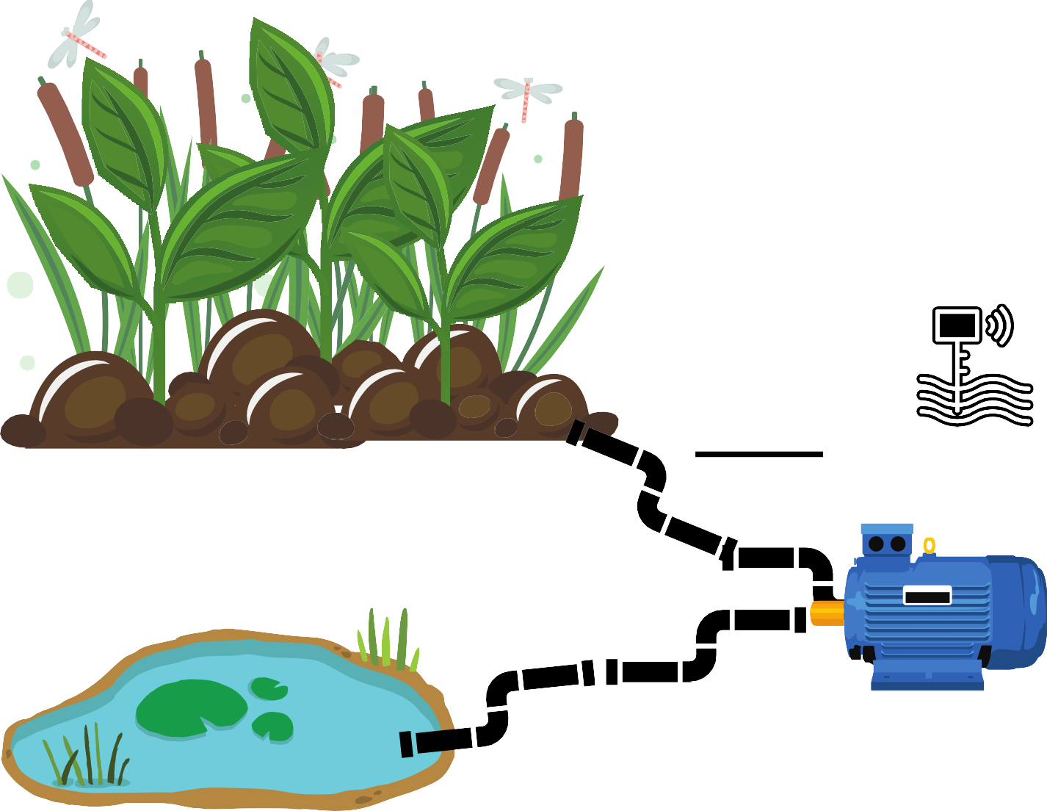

flAME sENsOr

Ph lEvEl sENsOr

# cEllulAr NETwOrk

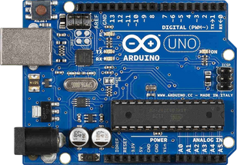

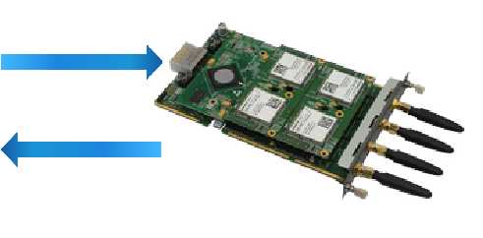**ArDuINO MIcrO gATEwAy MODulE rOuTEr INTErNET clOuD**

**cONTrOllEr**

wATEr AND MOIsTurE lEvEl sENsOr



**NOw I cAN MONITOr fArM AT ANyTIME AND**

**ANywhErE**

**MOTOr PuMP**